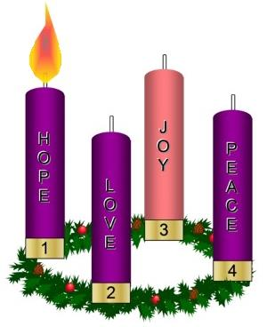
Dec 1, 2016
Dear Crusaders,
A short week packed with lots of exciting news. Our school alert system had a glitch this week that has now been rectified. We hope that you received the test call on Wednesday.
The SPPA is sponsoring a holiday shopping event for students on December 15. Donations are being excepted from which the students will be able to pay a quarter for family members gift giving.
Lotto Calendar Sales are coming in. Please return your $5 with a filled out ticket to the office ASAP to get in on the January 1 drawing. Calendar tickets may still be turned in at any time during Jan, however they will miss some opportunities for great prizes.
Collective books display in the lobby for browsing if you would like to place an order payments are due by 8 AM on tomorrow morning. See the complete list on the back of this newsletter.
Some of our students are participating in a local theater presentation of “Dear Santa” and “Jingle Jukebox” on Dec 3 & 10 at 7:00 PM and Dec 4 & 11 at 2:30 at the Orleans Municipal Building. Adults $10 and Children $6.
The American Legion will be hosting the showing of “The Christmas Carol” at the Barton Library on Dec 16th at 1:00 PM. We have a half day, enjoy this with your family and community.
Save the date: our Christmas Carol showcase will be Wednesday, December 14 at 6 PM. We're making great progress and preparing for our Christmas concert. Some students have been assigned parts with costume so they should dress accordingly, others should dress in their holiday best.
John Groff has local beef available for sale. Please check out our Facebook page.
Food Drive, Soldier Collection and Toys for Tots are being collected in the lobby. Thank you for your generosity.
Wreaths should be delivered by noon tomorrow. Please make arrangements to have your orders picked up by parent pick up at 2:40. Thanks.
Vocations Gathering at the rectory Dec 10, 11-1 includes lunch. All are welcome please RSVP or food prep.

