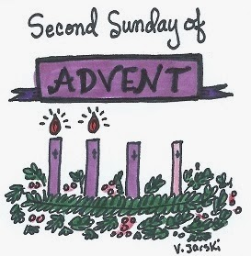
Dec 7, 2017

Dear Crusaders,

As we enter Advent week 2, we should be reassessing our lifestyles for the way of the Lord. Our church will host confessions on Tuesday.
Tomorrow, Dec 8, is a Holy Day: Immaculate Conception. Please join us at 8:30 AM for mass to celebrate the Conception of Mary.
It’s concert time! We’ll see you Monday Dec 11 at 5:45PM for a 6:00PM Show. This is free and open to the public, students should wear their holiday best attire. No Santa hats, camo, Carhartts or jeans. Thank you.
8th grade fundraiser- Basket Raffle flyer is enclosed. The 8th graders will be raffling the baskets at the concert. If you are interested in purchasing a ticket in advance they are $1 each or $5 for 6. Winners do not need to be present to win.
Family Gift Bizarre will be Friday Dec 15. You may send in your gently used small items for set up anytime. Students will be able to “shop” for gifts by bringing in a canned good for the food shelf. Only one item per family member in their immediate household will be honored.
January Winter Activities sign ups went home last week. Please return them soon so that we may make our roster and reservations.
Thursday, Dec 14 is Movie Day! The bus will load EVERY student and travel to St Johnsbury for a special showing of Wonder (available to grades 3-8) and The Star at 8:50 AM (NOTE THE EARLIER TIME). Showtime is at 10:00AM. Admission is $4 and open to the public. The concession stand will be open. Bag lunches only, please pack a drink for lunch. We’ll be eating our picnic lunch at the local rec center.
LAST Call for food donations, Toys for Tots, soldiers care packages and animal shelter collections. We have been able to pack two priority boxes weighing 25# each to soldier contacts from our school community. We filled two boxes for Toys or Tots, sent about 50# of supplies to the Animal Shelter and 100# to our rectory Food Bank. Thank you for your generosity! I hope you saw our article in the Vermont Catholic Magazine this month.
Dec 19 – Walking around Barton to go caroling with grades K, 1, 2, 7, 8.
Dec 20 – No After School Program.
Dec 21-Jan 1 Christmas Vacation

