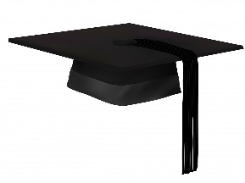
June 2, 2022
Dear Crusaders,
Happy June! We send our best wishes to our preschoolers and our 8th graders as tomorrow will be their last day for the school year. May the roots that you created here at Saint Paul’s Catholic School guide you well wherever you may be. Remember Saint Paul’s as your home, and you’re always welcome back.
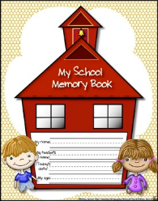
Next week will be our last week! Dress down all week. Although we should be comfortable, we still have to be Saint Paul’s Catholic School appropriate. If a student is questioned for their attire, there are plenty of uniforms in the uniform closet. Please come celebrate with us at Crystal Lake on Wednesday. We will be walking to Crystal with our classes at 10:30 AM and hope to stay till about 2:30 PM. In the event of inclement weather, we will move our trip to Thursday. Students may wear bathing suits under their clothes. You are encouraged to bring beach toys, but please label them. You should have a towel, water bottle, personal sunscreen, cold lunch, hat, and dry clothes. Please be sure to send a duffel bag or a backpack every day as we are trying to send home personal items each day.
Father’s Day Raffle tickets are due with money on Friday, June 10 to Mimi at the front desk.
The yearbooks have arrived! Our current 8th graders sold ads to sponsor the yearbook. They raised enough money to buy everybody their own yearbook! Please support these vendors and tell them how appreciated they are that they sponsored the Saint Paul’s Catholic yearbook. As a business owner, I can tell you that that means a lot.
June 10- Last day dismissal at 11:15 AM.

Volunteer opportunity:
- Are you interested in marching in any parades or riding on a trailer for a float? We are also looking for a small trailer that could be pulled by a car if possible or a large trailer. This would solve rain and/or heat for our volunteers. An easy up could even be secured to it. For instance: Derby 4th of July parade starts at 10am, line up is at 9:00 AM at the Elks Club. Contact April Roberts at 802-334-8242.
- Do you sew? The uniform closet has been sorted by a parent last week. We have a bag of stained or ripped shirts that need to have patches removed from and saved and another bag of long pants with ripped knees that could easily be hemmed for school shorts.
- Do you want a pressure washer? All the entrance rugs to the school need to be vacuumed and pressure washed before we return to school in August.

Have a great summer! This is the last newsletter for the year. Next week your school supply list and report cards will be included in your last family folder.

