Sept 28, 2017
Dear Crusaders,
Another HOT week concludes week 5 of school with a welcomed cool down. Thank you for sending a water bottle with your child. Please review the uniform policy from our handbook printed on the back. Patches are available at the office for $1.
Progress Reports will be issued next week.
Safe and Sacred renewal: If you’re up for the next chapter of the course, you may or may not get an email. Log on to your account by going to www.vtcatholic.org> Child Safety>LoginPortal. If you forgot your user name or password, simple request a new one via your email. Log in and scroll down UNDER the video to the course offering. You should see in the Action column an option to “take the Next Step”. When you click on that, it brings you to the next available course. Any volunteer work at school requires this training.
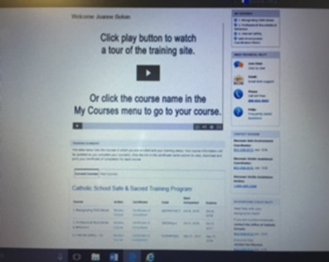

8th grader Cord of wood winner: _John Groff Congratulations.
SPPA meeting is set for Thursday Oct 5 at 3:30 in the Arts Room. There is Homework club until 4:00 and afterschool club until 5:00.
Rummage Sale Orleans Parish Hall Oct 5: 9-6 and Oct 6: 9-11AM. Drop offs Wed Oct 4: 9-4.

TONIGHT!!!! Restructuring meeting at the Orleans parish Hall immediately following the 5:30 Mass. Parish and school business to be discussed. School agenda items include volunteer service, tuition and fundraising.

Middle School Soccer Games Today @ Brownington 4:15
Tuesday @ Glover 4:00
Thursday @ Irasburg 4:00

Did you know we collect:
- Boxtops, they are worth $.10 each
- Price Chopper Advantage Card Numbers to share with the school. This does NOT affect your gas points.
- Ink cartridges get recycled to Staples for $2 each
DRESS CODE
The rules regarding the dress code at St. Paul School are to enhance the appearance of the school and promote self-esteem and pride in performance. Children should come to school neatly dressed at all times. The Administration reserves the right to contact the parent if it becomes necessary to question attire. The following are St. Paul’s uniform regulations:
Boys Uniform
- Navy blue pleated double-knee pant
- Navy Blue Pleated Shorts with matching solid red, white, blue or black crew socks – usually worn Aug-Oct and May-June
Girls Uniform
- Navy Blue Skirt or Scooter (three-tab, flower buckle, pleated, kick-pleat, and two-tab…not fade-away, long, side-pleat, or grosgrain). Skirt length must be within 3 inches from the top of the kneecap to 1 inch below the kneecap
- Navy Blue Pleated Slacks
- White or Navy Blue Nylon Cable Knee-High socks or anklets. They must be matching, solid red, white, blue or black
- Sneakers and shoes: rear of heel 1 3 /4 inch height maximum
- All hair accessories: conservative design: navy blue, black, dark brown or white
- Earrings: one set in the appropriate position (ear lobe only) Flat earring for safety purposes-no loops or dangly earrings, not larger than a dime.
- Fingernails: No nail polish or no fake nails. Polish is a grade 7/8 privilege.
- Necklaces will not be visible, unless religious and blest • Bracelets: one per wrist, maximum of 1inch width
- Makeup of any kind is not permitted. Light make up is a grade 7/8 privilege
- Undergarment tops or brassieres: White
ALL STUDENTS:
- Royal blue, red or white short or long sleeve polo shirt with St. Paul’s patch (sold for $1 at the office) on the left chest.
- Navy blue vest or sweater (no logos or designs). SPPA sells a navy hoodie that is allowed.
- Hair: Neat and clean cut. Conservative highlights are allowed (no blues, greens, or blond racing stripes. If you’re not sure, please see the principal). Exaggerated hairstyles will not be permitted. (Mohawks, tails, etc.) If you not sure, it’s probably exaggerated. Hair will not obstruct vision
- Uniform items with small holes must be mended. Items with large holes or large permanent stains must be replaced
- Tattoos of any kind will not be permitted
- Body piercing of any kind will not be permitted other than the earrings allowed for girls only as previously stated.
- Hats may not be worn in school

