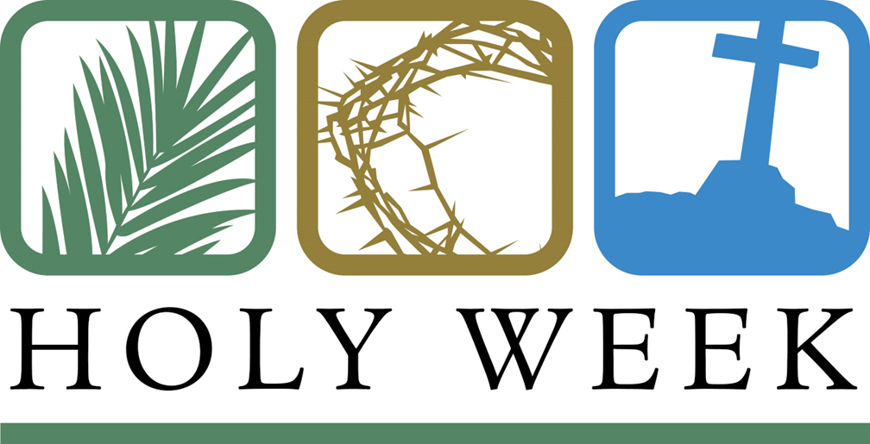
April 5, 2023
Dear Families,
Holy Week has us busy wrapping up Lent. Please join us for the following celebrations:
- Holy Thursday Ceremony- St Paul’s Church 7:00 PM
- Good Friday Live Stations 8:30 AM
    - Ceremony St Paul’s 7:00 PM
- Easter Vigil – St Paul’s 8:00 PM
- Easter Sunrise service Morning - Jay Peak 6 AM!
    - Free tram rides beginning at 5:00AM.
- Easter Morning - 8:15 a.m. St. John Vianney and
10:30 a.m. - St. Theresa’s
Registration- Regular registration for next year is now open. Please log into your Ren Web Parent Portal and select reenroll. Book and registration fees of $350 are due to the front office by June 1.
Mother’s Day Raffle – We’ll be selling raffle tickets for Mother’s Day. Do you have a gift that you would like to donate ($50+ in value)? Please send them to the office by Monday April 10. This gift will earn you $25 in tuition credit. Thank you!

Dates
Good Friday – Live Stations at 8:30 AM and dismissal at 11:15.
April 13 -Thursday – Field Trip to Northwoods
April 14 - Fri – School Mass
April 15- April 23 VACATION
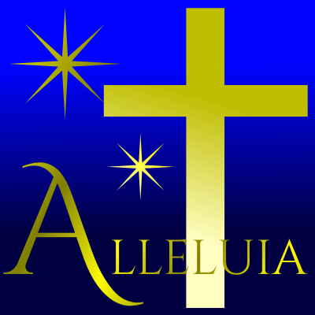
April 26 – Concert at the Municipal Building at 6:00 PM.
May 1-5: Standardized Testing.

Happy Easter! He is risen!!!

