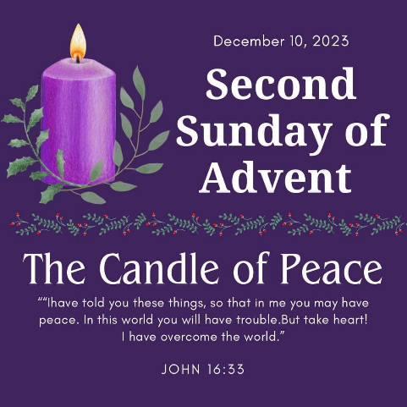
Dec 10, 2023
Happy second week of Advent!!! Peace be with you! In honor of this week please see below for special clothing themes each day.
Well done everyone on a glorious Christmas concert showcased last week. Kudos to Mrs. Johnstone. Also, a great thanks to The Roberts, Fortin and Ward family for the offering of dinner before a concert. Great idea!
We have a busy week ahead of us and strange weather. Be on alert and always err on the side of caution. Thank you for calling the school by 7:40 if you will not be in attendance.
School invoicing went out on Friday. Thank you for paying in full by Friday December 15, 2023.
Lotto Calendar money and tickets may be turned in this week to be certain we have them submitted by Jan 1, 2024.
2024 Annual Appeal goal of $10,000 kicked off last month. Please consider sharing the fundraising campaign with your long-distance friends and family. We are looking for any donation but are challenging 128 donors to give $128 in honor of our 128th anniversary.
Happy 128th Birthday to Saint Paul's Catholic School. Please consider being one of our valued 128 donors by donating $128 towards our annual appeal to help us reach our goal.
Donations can be made to:
St Paul's Annual Appeal and mailed to
54 Eastern Ave,
Barton, VT 05822

See you Tuesday Jan 2, 2024. We go to Northwoods on Thursday Jan 4. Chaperones are encouraged. Please RSVP to the school front office.
A very blessed and Merry Christmas to all of you!
Dec 11-15
 | Monday | Tuesday | Wednesday | Thursday | Friday
 | Mindfulness | Christmas Shop (a quarter or food shelf donation per gift)  Siskins here | Performing Arts  Prek Happy Birthday Baby Jesus/ Christmas Party | Trip to Northwoods | Mass  K-8 Happy Birthday Baby Jesus/ Christmas Party
Clothing Theme | Dress in Red and Greens/ Cozy | Ugly Sweater and Jeans | Dress up FANCY!!!! | Dress down | School Uniform

