Jan 11, 2023

Dear Crusaders,

Winter has finally arrived. Please have your child dressed in snowpants, jacket, boots, hat and mittens as they get out of the car in the morning. We stay outside as long as the wind chill is above 10 degrees. All students should join us at the Flag pole entry prior to 8:00. The front door should ONLY be used for school business or students that are tardy. This will help eliminate office congestion.

Tomorrow is our **first trip to Northwoods**. The temperature will hover about 20 degrees in the morning, according to the forecast. Dress in layers and cover your faces! Most of the day will be spent outside with warm up breaks. Learning to appreciate the great outdoors is a wonderful goal. The bus will leave at 8:30.

Enclosed is a **permission slip** for our next field trip on Jan 26. We are going to the Kingdom Horse Drawn Sleigh Rides. Chaperones are welcomed, please RSVP on the enclosed slip.

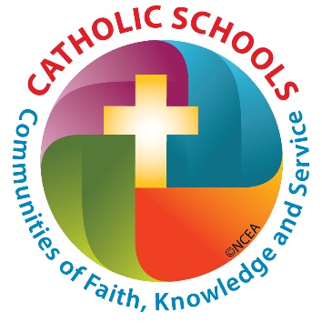**Catholic Schools Week** is a spirit week that kicks of early for us this year! We are hosting a Community Appreciation lunch on Wednesday Jan 25. It’s the Feast Day of St Paul, the patron of our school. We’ll have mass in the morning at 8:30 and prepare for our guests. Every student may invite 2 guests to join us. Their invitations are being prepared this week. Then that weekend (Jan 28 and 29) we invite you all to attend a Catholic Mass in uniform to show your solidarity. The rest of the week’s schedule is enclosed. Everyday there is an explanation of what the focus of the day is, the dress code and activity.

**Dates:**

1/12 Thurs – Trip

1/13 Fri – Early dismissal

1/16 Mon - Closed