1/25/23
Dear Families,
May St Paul’s spirit guide you and continue to bless our school on this his feast day.
A great thank you to Mimi and her volunteers for providing a great lunch today in appreciation for all our volunteers and supporters that contribute to our success.

Tomorrow we will go on our next field trip to the Sleigh Ride in Brownington. Dress in layers. Pack a cold home lunch. Bus leaves at 8:30 AM. We’ll return to school by 1:30 PM.
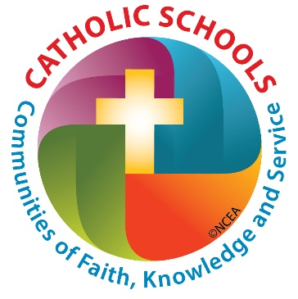
Next week is Catholic Schools Week. Activities and themes were sent home last week.
- Monday is Sports Spirit Day. Hats will be allowed if they go with your team spirit, except at the table and during prayer.
- Sign ups for Thursday’s talent show will be tomorrow and Friday. Students need to sign up with Mrs. Beloin and run throught their act for approval.
- Mass next week will be Friday Feb 1, the feast day of Saint Blaise. The traditional blessing of the throats will be administered. May we all stay healthy this winter.
- Remember to attend a mass in your school uniform this weekend! It’s our simple way of saying thank you to all our local patrons.
Mardis Gras Party – the parish is selling tickets for a great evening of food and entertainment on Sat, Feb 18. Tickets are available in the front office ____(Please add details from the poster over the copier__

