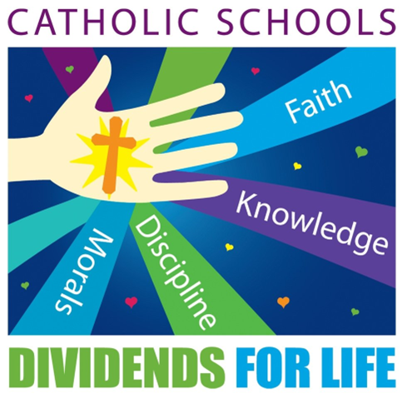
January 25,2024

Saint Paul, pray for us! Today is the feast day of our patron saint of our school. Saint Paul is a wonderful symbol of God‘s unending love for us. Even as a sinner, Saint Paul was able to convert his way and dedicate his life to God. Thank you for being part of our Saint Paul’s Catholic School community.

Thank you for your participation in our Appreciation Luncheon yesterday. We especially appreciate Mimi and her team that served over 150 meals. It was wonderful to have a full school again.

This weekend kicks off Catholic Schools Week. Please make an attempt to attend a Catholic mass this weekend in school uniform. Showing our church community that you were proud to wear your uniform is a wonderful visual to our community. Enclosed is next week’s themes on a daily basis.

Progress reports are enclosed. Please feel free to sign the enclosed progress report and return it to your teacher. Students in grades 5-8 have access to grades on a daily basis using Ren Web. If you need help accessing that, ask you child or contact Mr T.

Dates:
- Thursday-February 1 mass at 8:30 AM. All are welcome!
- Fish Fry Fridays in March- March 1, 8, 15, 22. Dinners will be served from the municipal building this year. There will be no pre-orders this year. Meals will be first come- first served. Takeouts are available. Walk-ins are welcome. Thank you for supporting our school.
- Monday, April 8 eclipse- we will be having a late dismissal at 4:00. No buses will be running in the afternoon. All families are invited to come to school at 2:30 to participate in eclipse activities and prepare to view the eclipse. Parent pick up is at 4:00.
- Wednesday, April 10 -concert at the municipal building. Finding Nemo will be performed.
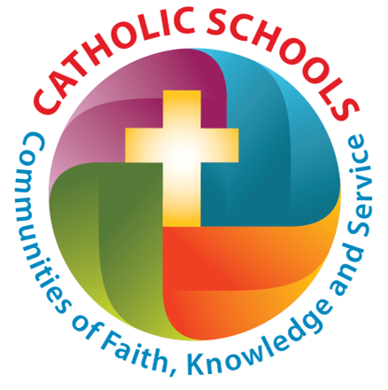
- May 6-10 standardized tests will be administered to students in grades 1-8 throughout the day. Please refrain from making any appointments or picking up early during that week of school since make up testing is very difficult to coordinate.

