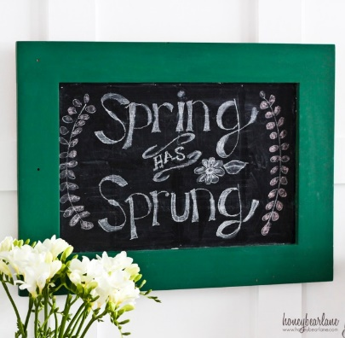
March 22, 2023

Dear families,
Last Friday was the close of the semester. Enclosed you will find your report cards. We’ll see you tomorrow for conferences. It’s a half-day dismissal at 11:15.

Friday is a student make up day. Students are going to Northwoods all day. Please remember to pack two drinks, a cold lunch, layered clothes and outdoor clothing. It is a dress down day. Chaperones are appreciated.

Next week’s field trip is to Jay Peak Ice Haus for ice-skating. Students are encouraged to bring their own skates and a helmet. After leaving Jay Peak we’ll be going to Couture’s Maple Shop in Westfield for a tour of the sugarhouse and sugar on snow. Permission slips were enclosed in last’s family folder. Chaperones are always welcome.

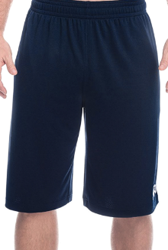
Spring has sprung, supposedly! The weather in Vermont is very temperamental. From freezing cold, to rain, to 60 by the afternoon, we have to be prepared for everything. Please continue to send your child to school with hat, mittens, a winter jacket, snow pants, and boots. Even when the temperature is warm, the snow is melting and everything is wet, wet, wet!

If you need to rummage through our uniform closet to get the next size up in pants, shirts, shorts and skirts bring a laundry basket and fill your basket! You may deposit clean, repaired uniforms to our closet by size.

Save the date:
- April 7 Good Friday is another student make up day. Students in grades 5-7 will be presenting the LIVE Stations of the Cross at the church at 8:30. This presentation will last less than an hour and all are welcome. It is an early dismissal at 11:15. Why not stay the morning and attend the Stations of the Cross with us?
- Wednesday, April 26 at 6:00 PM at the Municipal Building in Barton will be our spring concert. This is a free show all are welcome. This year’s theme is Americana.

