March 8, 2023
Dear Families,
We hope you enjoyed your extra time with your families last week. Six more weeks until our next vacation. Second semester ends March 17 and an opportunity to meet for conferences will be offered March 23 12-3:00. Please see your homeroom teacher for sign- ups either in person or by phone.

Friday Fish Fry – Thank you to Mimi and her team for setting up a successful fish fry. We need your help! Please send in one pan of brownies or bars, cut into 9 pieces. Parent pick up will coincide with the first Fish Fry pick up. Thank you for your patience. We will do our best to keep the line moving.

Dates:
March 10 – Winter Activities to Northwoods. Chaperones are encouraged. Bus leaves at 8:30 AM.
March 24 – STUDENT DAY!!!! WE ARE MAKING UP A SNOW DAY. Winter activities to Northwoods with 3 staff and as many chaperones as possible, since teachers are in a class.
April 7- STUDENT DAY!!!! WE ARE MAKING UP A SNOW DAY. 1/2 Dismissal (Parent pick up at 11:15 ONLY). Live Stations of the Cross will be performed at 8:30 AM. All are welcomed.

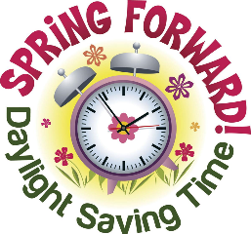
Daylight Saving Time starts this Sunday! Spring ahead to get to church on time on Sunday.

