November 17, 2022
Dear families,

We knew it would come. But somehow the snow still caught us off guard. If your student needs snow pants or jackets, please have them come look at the school closet. We enjoy a lot of outdoor winter fun time. All students must have boots, jackets, gloves, and snow pants on a daily basis. They should also be wearing socks taller than their ankles! Water bottles are encouraged but hot chocolate and coffee should be consumed before getting out of the car.

Lotto calendars are enclosed. All families are obligated to sell 20 or buy them all for $100 as part of your tuition agreement. Prizes will be drawn starting January 3 so get your tickets in to us before the Christmas holiday break starts or immediately on Tuesday, January 3. Tickets will only be submitted with payment. Families are encouraged to write one check to the school. Good luck.

Wreaths are getting picked up on Sunday morning and sorted. It is our hope that your wreath order will be picked up on Monday at Parent pick up time or at drop off time in the morning. I have not seen the candles yet. As soon as they arrive, I will sort them and get them out to you.

Conferences for report cards have been taking place this week. Thank you for chatting with your teacher about your child success. As always please do not hesitate to bring up any goals or challenges that you may be seeing at home that we can all work on together.

Next week is a short week so that staff and students may celebrate with their families. There will be no family folder or newsletter next week. If you plan on being out of school, please remember to let the office and the teachers know. Done in advance helps the teachers plan for missed assignments.
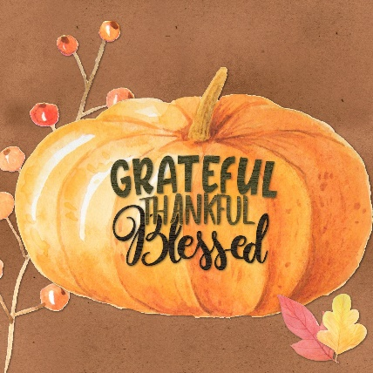

Happy Thanksgiving.

