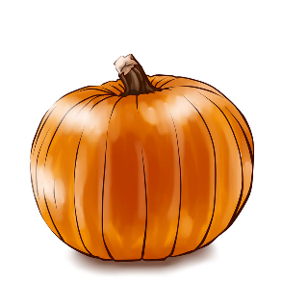
October 13, 2022
Dear families, what a wonderful visit we had yesterday with Bishop Coyne! Mass was wonderful as the students were very involved. We prepared a song that went with the readings that was super silly and super fun. Ask your child what the fruits of the spirit are. He visited the school afterwards and was very impressed with the student questions, attention and the teachers. We have something very special here at Saint Paul’s Catholic School and I’m proud to be a part of it.

Lotto calendar – it’s time to start collecting prizes. If every single family were just to bring in one or two prizes the calendar will be filled within a week! Prices should be valued at $25 or more. We need to gather prizes in the next three weeks, print the calendar the two weeks before Thanksgiving and sell for one month before December 16. Any prizes solicited with a value of $50 or more will gain a $25 credit on your bill, as a thank you. These can be from your personal business; one you work for or one you solicit. Please consider services or product that you may offer: How about ¼ cord of wood? Dump truck of seasoned manure for the garden? Dump truck of mulch? A BRAND new gift in the closet that you never used? Have you thought about personally sponsoring a $50 gas card or gift certificate (remember $25 tuition credit! So you’re only really donating $25)? Products or gift certificates can be brought to the office for inventory as soon as you receive it. Thank you!

Wreath and candles sales are going strong. Orders with payments need to be at school by October 27.

Progress reports are enclosed. We are at the halfway mark of our trimester. 1/6 of the school year into our structures and routines and students and staff are bonding well together. Thank you for your support from home. We couldn’t do it without you. Teachers are always available by email or by appointment. If you have any concerns after asking your student about their work, please feel free to contact the teachers.
The weather is constantly shifting. If you need to restock your uniforms for long pants, long sleeves and sweaters, please make an appointment to come to the uniform closet. If you need a new winter jacket, please contact the office. We have a closet of gently used or brand new jackets in our circulation donated by the Knights of Columbus.

Have a good weekend.
Thank you for being a member of the Saint Paul’s Catholic School community.
Go Crusaders!

