9/8/22

Dear Families,
Another week has come to a close. Thank you for supporting us as we open our school this year. Tomorrow we will celebrate by going to the Barton Fair. It will be HOT. Send in a hat, multiple water bottles, a lunch from home and sturdy walking shoes. You may wear your choice of bottoms, and a red St Paul’s uniform shirt. A great thank you to the donors who made this happen. No additional money is needed. We will have a chance to buy a small refreshment prior to leaving. All carnival games and vendor purchases can be accessed with your families AFTER the bus leaves at 2:10.
Parking shifts are needed on Sat and Sun 12-8PM. If you have not signed up for your shifts, please contact Mrs. Beloin ASAP. See your email yesterday for a sign up incentive.

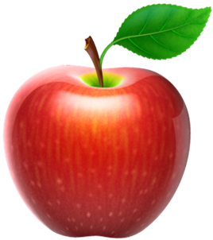
School Mass Thursday 8:30. All are welcomed.
September 16 – early release at 11:15. Teachers have meetings so please be sure to be here by 11:30.
September 20- Apple Picking trip. Permission slip is enclosed. Families are welcomed.
September 23 – School Picture Day. Enclosed is a flyer. If you have multiple students in the school and would like them photographed together, you must buy a separate package. Please make the check to Whipple’s and return the envelope to school ASAP. We will keep them until picture day.

Thank you to all who volunteered to work the fair shifts or that organized the Golf Tournament this weekend. The school community appreciates all your efforts.

