September 19, 2024

Dear families,

What a wonderful week we’ve had at school with gorgeous sunny days. We were blessed with a beautiful field trip on Tuesday and I hope you’re enjoying all your apples. I appreciate any pictures that families take as they gather at Saint Paul’s for us to share. Positive marketing is very important to us.

Friday, September 20, no p.m. bus. Public schools have a half-day, yet we will remain in session all day.

Fridays, September 20 and 27 school mass at 8:30 AM. Please join us.

**Volunteer opportunity!** The flooring in kindergarten is finally going to get done this Saturday! On Friday afternoon at 1:45, we will be emptying the kindergarten room into the hallway. Anyone who wants to come a little earlier for parent pick up to assist will be greatly welcomed. The contractors will work all day Saturday and the room will need to be put back together on Sunday from 11AM-1PM. Anyone who would like to join us on Friday or Sunday can simply show up at school. If you have lifting aids, a dolly, or sliders, it would be very helpful.

Did you know that we are an aluminum **can tab** collection site for the Vermont Lions Club? Collect them in baggies and send them to school. Just another way we can help the community.

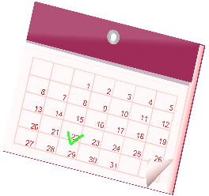**Lotto Calendar-** We are collecting prizes. Although we sell in Nov and Dec, we need to build the calendar late October. It’s a daily prize calendar for January 2025. If you personally donate a prize or Gift Certificate valued at $50, we will credit your student account $25 per prize. If you would like to solicit a few prizes for us, please contact Mrs. Beloin. We’ll create a list so no business is asked more than once. We appreciate tangible items, gift certificates for services, gas cards, CASH (think businesses without products…lawyers, car dealers, realtors, banks, dentist, etc).

I can commit to donating: ____________________________________valued at $_______.

________ I would like to help organize this fundraiser by soliciting prizes.

Name: ___________________________________ Phone: _________________

Email: ___________________________________